**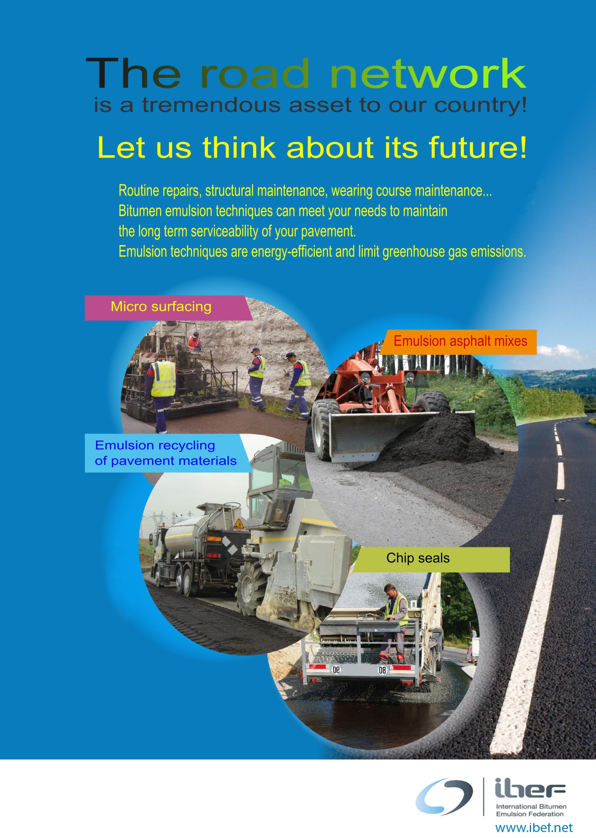**

 **  
 www.ibef.net**

**International Bitumen Emulsion Federation**

**Pavement Preservation a global challenge:**

**the contribution of bitumen emulsion industry**

|  |
| --- |
| Society cannot function without roads |
|  |
| ***World Highways April 2013*** |

Introduction

|  |  |  |
| --- | --- | --- |
| Roads are primary assets of nations. In every country, they bear most of the passengers’ traffic as well as the transportation of goods. The predominant role  of the road networks at every scale makes their preservation a highest priority for all communities.  However, it appears in many countries that the backlog of outstanding road maintenance has caused irreversible deterioration of the road network.  In other words, delaying road maintenance is false economy.  The shortfall in investment in maintenance generates higher risks of accidents, problems of congestion, increased noise and a reduced service to society.  In this way, road maintenance should be seen as  a whole, as clearly summarized in the graph below. | |  |
| ***World Highways May 2011*** |
|  |  | | |
| ***SABITA 2010*** | | | |

**Actual facts confirm such principles.**

|  |  |
| --- | --- |
| ***World highways March 2013*** | ***Business Week April 2013*** |

As a result there is a crucial need of pavement preservation on existing road network.

Such need has been recently underlined at the 2013 Annual Summit Funding Transport held in Leipzig, in the declaration of Ministers of Transport:

“Transport infrastructure is much more than asphalt, concrete or steel, it is the backbone  
of national economies, providing connections for people and goods, access to jobs and services, and enabling trade and economic growth. [….]”

The Ministers recognize that “sufficient infrastructure investment and maintenance is required to ensure a robust, high-quality, sustainable transport system”. [….]

**The markets today**

The 2008 crisis have severely impacted public road expenditure. This is a global trend even if the magnitude of this impact differs from a country to another.

Such scarcity of funds should lead the road industry to be watchful in order to raise the full awareness of the road users and politicians about the value of pavement preservation. Refer to Report 742 “communicating the value of preservation” by the National Cooperative Highway Research Program (2012). [*http://onlinepubs.trb.org/onlinepubs/nchrp/nchrp\_rpt\_742.pdf*](http://onlinepubs.trb.org/onlinepubs/nchrp/nchrp_rpt_742.pdf)

Scarcity of funds has lead road agencies to make the best use of the moneys available, identifying priorities and selecting   
the appropriate technical solutions. Tools have been developed such as Pavement management systems that make such optimization workable.

Bitumen emulsion techniques have their full role to play within a wide portfolio of solutions that are made available by the road industry.

The annual volumes of bitumen emulsions have remained stable at a level of more than 8 million tons that represents nearly 10% of the whole bitumen used for road works.

The top ten countries represent close to 75% of the volumes, with USA, France and Mexico as leading producers.

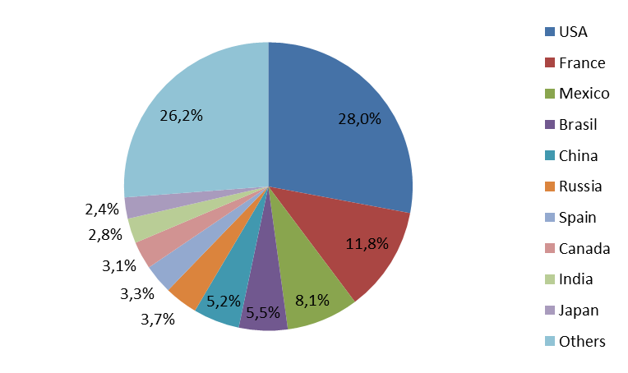

***Bitumen emulsion top ten producing countries***

**Driving factors**

Globally, the road industry has been facing a double challenge: costs increases (e.g. bitumen price have more than tripled on a 10 year period) and shrinking markets due to public budgets restrictions.

On the other hand, the growing awareness of the need for pavement preservation should be a booster for cost efficient solutions such as bitumen emulsion based techniques, when appropriate.

Moreover, Health Safety and Environment requirements are new incentives for updating the panel of existing techniques and develop Research a Development works for innovative solutions.

Such trends are not limited to a few countries: they apply on a worldwide scale, encouraging communication and beyond, such as through technology transfers.

|  |  |
| --- | --- |
|  |  |
| ***Glass fiber reinforced chip sealing*** | ***Synchronal chip sealing*** |

**Answers from the industry**

Being challenged by a fast changing context, the industry has developed systems that are meant to be closer and closer to their customers’ needs. Such optimization starts with a comprehensive knowledge of the road networks, selecting the most appropriate maintenance technical solution within a constrained budget. In other words, the customer wants more for less.

|  |  |
| --- | --- |
|  | 20060614_02_000014 |
| ***High speed data acquisition system*** | ***Image processing: crack records*** |

Such an optimization, i.e. pavement management system, requires a higher expertise from both the road owners and the road industry.

Upstream its main construction and maintenance activities, the road industry is now more and more involved in data acquisition, processing and design. Such integration allows a better technical and financial optimization of the maintenance projects, for the full benefit of the road owners and the road users.

Beyond these parties, it is clear that the bitumen industry needs to be fully aware and committed, being part of the supply chain.

**Conclusions**

With both public budgets and private sector resources under constraint, government authorities and industry must together seek new ways of ensuring stable, long-term funding for the sector.

Within this context the Industry has initiated a dedicated forum which will take place in Paris February 2015: Pavement Preservation & Recycling Summit Paris 2015.

|  |
| --- |
|  |



***S/D USIRF 9, rue de Berri, F75008 Paris,*** [*www.ibef.net*](http://www.ibef.net)

**The International Bitumen Emulsion Federation** has been founded in 1996.

It groups together national associations of bitumen emulsion manufacturers.

Its objectives consist in promoting the use of bitumen emulsion and exchanging information related to promotional means, standardization, health, safety, and environment along   
with the development of bitumen emulsion applications.

The IBEF is an international vehicle for information and technology exchange related to bitumen emulsion.

It organizes and sponsors periodically conventions dedicated to bitumen emulsions, and, more broadly, to pavement preservation.

The IBEF gathers members from 20 countries, representing more than 75% of the bitumen emulsions produced worldwide.

|  |  |
| --- | --- |
| Asociacion Mexicana del Asfalto, AC |  |
| Asociación Técnica de Emulsiones Bituminosas |  |
| Asphalt Emulsion Manufacturers Association |  |
| Association Marocaine des Routes | Logo AMR |
| Associazione Italiana Bitume Asfalto Strade |  |
| Australian Asphalt Pavement Association |  |
| ENFALT Emûlsiyon ve Asfalt Tesisleri A.S |  |
| Fachverband für Bitumenemulsionen und Straßenerhaltungsbauweisen e.V. |  |
| Hindustan Colas Ltd |  |
| ISCO Industry Co., Ltd. |  |
| Japan Emulsified Asphalt Association |  |
| MeadWestvaco | [MWV MeadWestvaco logo](http://www.meadwestvaco.com/index.htm) |
| Norwegian group of bitumen emulsion producers |  |
| Ooms Civiel BV |  |
| Patpribor Odd |  |
| RAD LLC | C:\Users\n_guseynova\Desktop\for presentation\logo.png |
| Road Emulsion Association Ltd |  |
| SFERB - Association of French Road Bitumen Emulsion Manufacturers |  |
| Southern African Bitumen Association |  |
| Tipco Asphalt Public Co. LTC | http://www.tipcoasphalt.com/images/logo_footer.png |

**Save the date!**

**February 22nd - 25th, 2015. Palais des Congrès - Paris**

|  |
| --- |
|  |



|  |
| --- |
|  |